 | Year 12 Methods  TEST 4 2019  Friday 23 August  TIME: 45 minutes working  One page of notes is allowed.  Calculator Assumed  46 Marks 6 Questions

Name: _______________________________ Teacher: ___________________________
Note: All part questions worth more than 2 marks require working to obtain full marks.
Question 1 (8 marks)
Consider the function .
- Sketch the function on the axes below showing all major features. (3 marks)
Solution
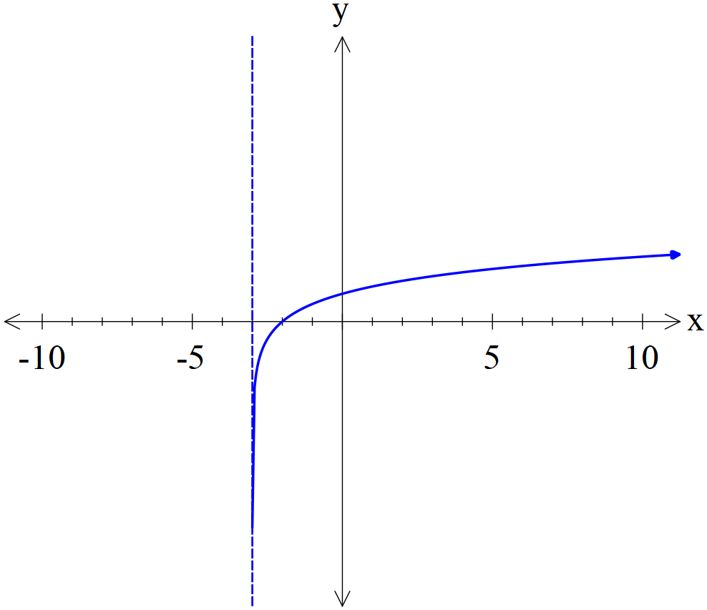
Specific behaviours
asymptote at x=-3
shape
positive y intercept

- Determine the value of given that . (2 marks)
Specific behaviours
converts to a power statement
expresses p in terms of a

- Consider the new function , determine the x coordinate where on this new function. (Note; is the same constant as above.)
Specific behaviours
obtains correct equation for x
uses a power statement
final expression for x in terms of a
(3 marks)

Question 2 (15 marks)
A company makes circuit boards to be used to make computers. The length of the circuit boards is estimated to be Normally distributed with a mean of 35 cm and a standard deviation of 16.7 cm.
A customer will only buy circuit boards that are between 22.5 and 41 cm.
- Determine the probability that a circuit board will meet the customer’s requirements.
(2 marks)
Solution
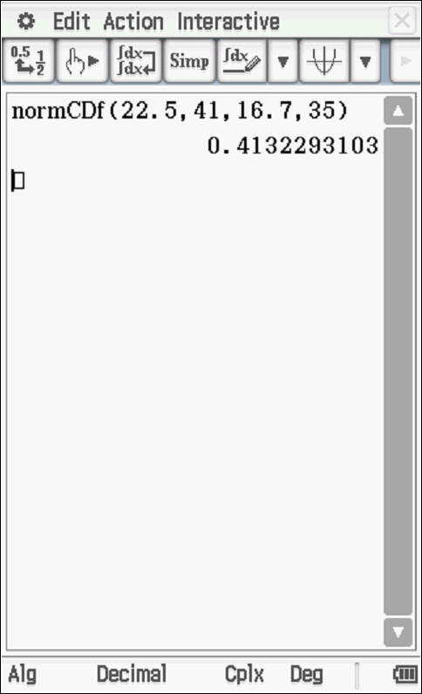
Specific behaviours
uses correct parameters
states probability (at least 2 dp)

- If the company made 20 circuit boards, determine the probability that at least 12 boards would be suitable for the customer. (3 marks)

Solution
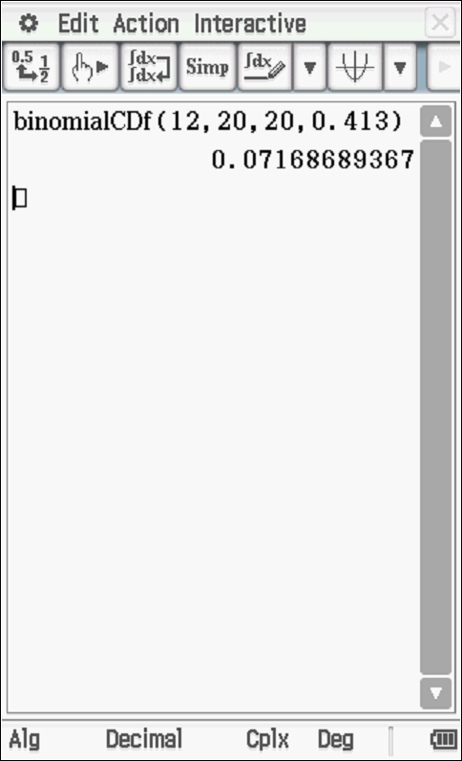
Specific behaviours
states binomial distribution
uses correct parameters
states probability
Note: Answer only- 2 marks out of 3

The government will tax the circuit boards made by the company according to its length. Complete the table below by determining the probabilities to 4dp.
- (4 marks)
Solution
Length of circuit board
Tax $ | $5 | $7.50 | $9 | $11.50
Probability | 0.0975  Or  0.1156 | 0.2668 | 0.5021 | 0.1155  Or  0.1336

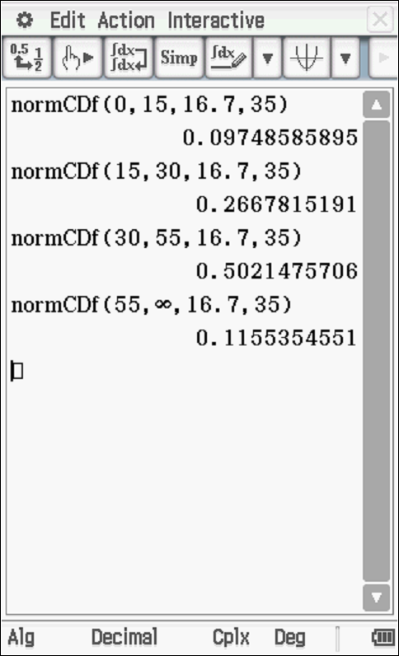

Specific behaviours
at least two correct probs
at least 3 correct probs
all four correct
all rounded to 4 dp

- Determine the expected tax bill for a circuit board. (2 marks)
E(Tax)=$8.49 or $8.43 or $8.54
Specific behaviours
states to at least 2 dp
states units

- Determine the standard deviation for the tax of a circuit board. (2 marks)
Standard deviation =$ 1.635 or 1.686 or 1.669
Specific behaviours
states to at least 2 dp
shows calculation
Note: full marks for answer only, no need for units

- Show one reason why the Normal probability model is not appropriate for the lengths.
(2 marks)
Solution
0.018 which cannot be as length cannot be negative.
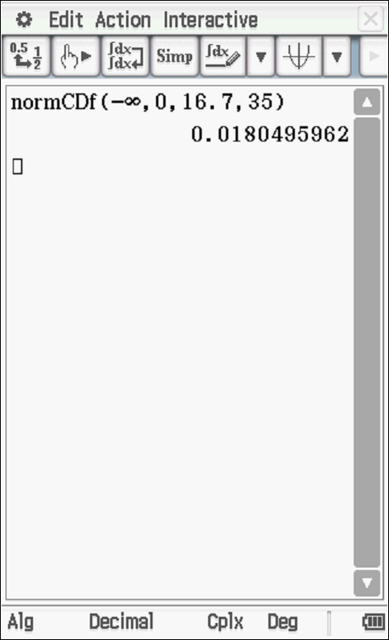
Specific behaviours
states that lengths cannot be negative
states prob that length is less than zero

Question 3 (4 marks)
The exam data for a cohort of Year 12 Methods students at a school has a mean of 72% and a standard deviation of 22%. The Head of Department needs to scale the results so that the mean is 60% and a standard deviation of 15%. This will be done by multiplying the original scores by a constant and adding a constant (any order). Determine two possible pairs values of and the order they should be applied.
Solution
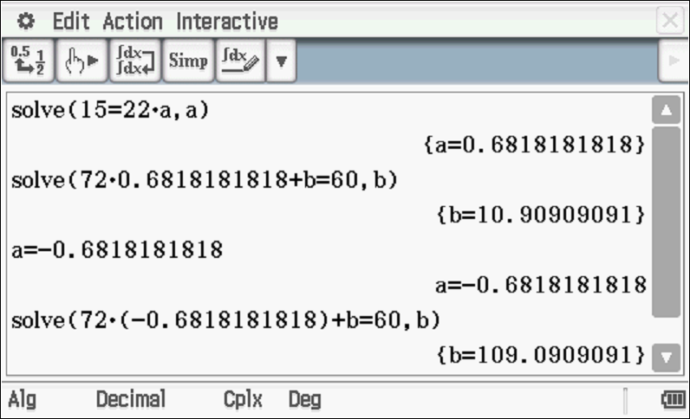
Specific behaviours
shows an equation for value of a
shows an equation for value of b
solves for one pair of a&b values stating order
states two possible pairs of a&b values and stating order

Question 4 (3 marks)
A pharmaceutical company wishes to gather information on a new form of headache tablets.
Comment on whether there is any bias in the following sampling methods, give reasons.
- People were surveyed outside a dental clinic. (1 marks)
Bias as dental patients more likely to have headaches due to dental pain than average.
Specific behaviours
States bias with a reason

- People waiting at a central bus station in the city. (1 marks)
No bias as not connection between headaches and mode of travel in general
Specific behaviours
states no bias with a reason
Accept a reasonable argument of bias with reason for this part ONLY

- People were contacted using random mobile numbers. (1 marks)
Bias as only people with mobiles contacted-those with landlines only are ignored
Specific behaviours
Bias stated with reason

Question 5 (10 marks)
A probability density function is defined as the following.
where is a constant.
Determine the following.
- the exact value of . (2 marks)
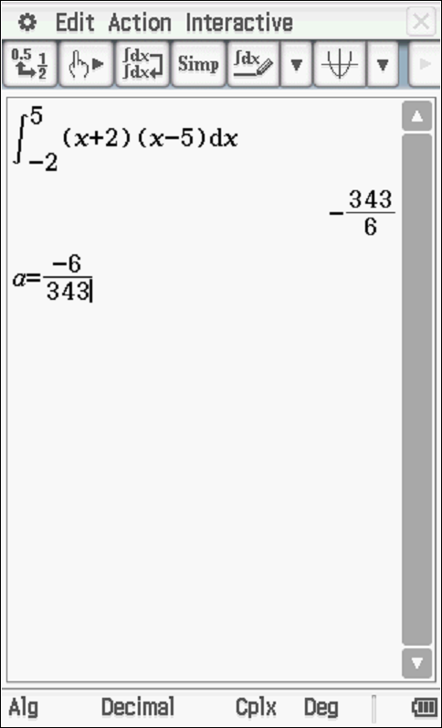
Specific behaviours
integrates function above
states exact value of a

- (2 marks)
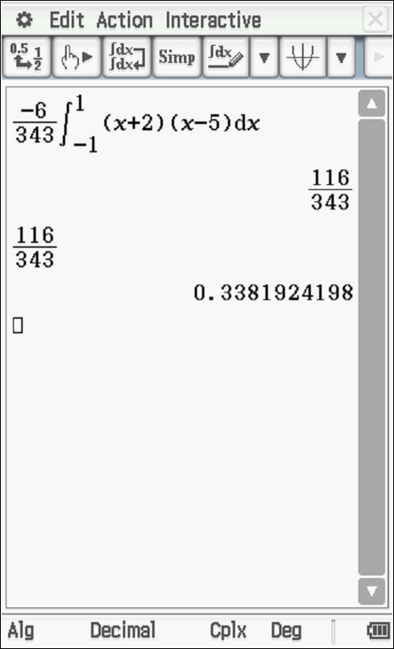
Specific behaviours
integrates over correct domain
states prob to at least 2 dp or exact

- the mean of . (3 marks)
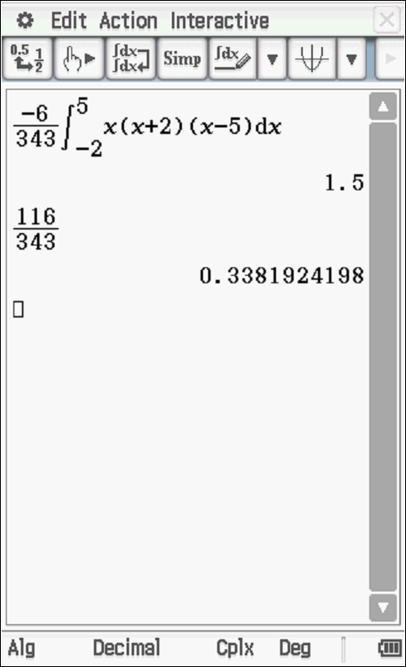
Specific behaviours
uses correct integral
limits correct
states mean (Note: 2 marks for answer only)

- the standard deviation of . (3 marks)

Solution
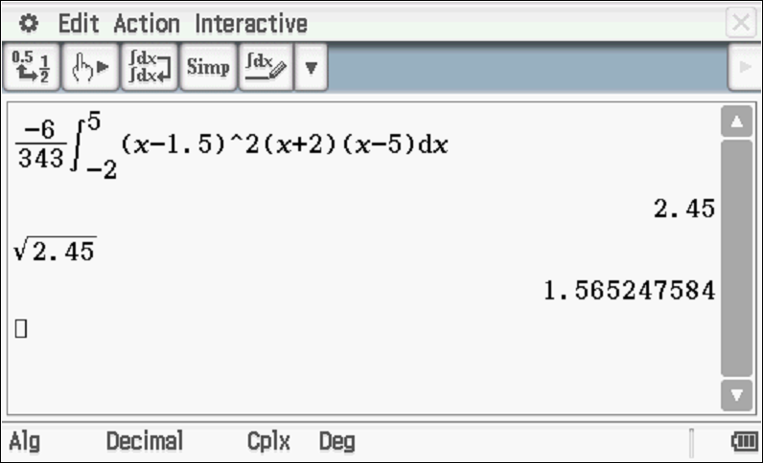
Specific behaviours
uses correct integral for variance
uses correct limits
states the standard deviation (i.e. square root of variance)

Question 6 (6 marks)
It is believed that a toy company produces defective toys at a proportion of .
- A consultant wishes to determine the true proportion of defective toys within 5% and with a confidence of 90%. Determine how many toys should be taken for sampling.
(3 marks)
Solution
v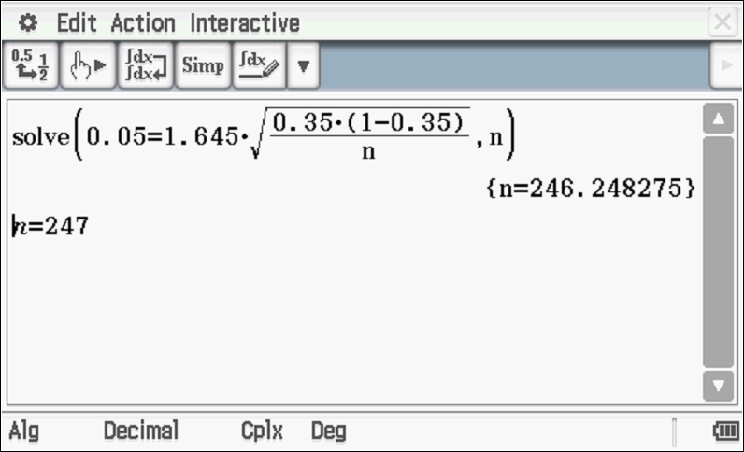
Specific behaviours
uses appropriate z score
sets up an equation for n
states a rounded up value for n

- A year later another sample is taken and a 95% confidence interval for the proportion of defective toys is calculated as . Determine the sample size. (3 marks)
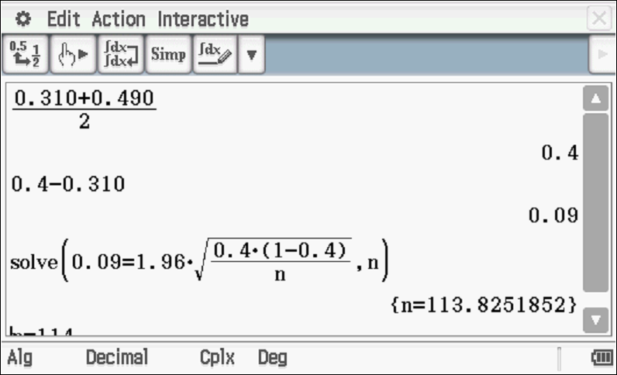
n=114
Specific behaviours
uses correct p value
sets up an equation for n with correct z score
states a rounded up n value

